Psychology – Research and complete the worksheets

What is Psychology?

The Biological Approach
This approach argues that all human behaviour is determined by biology, this includes the role of the brain, nervous system, neurotransmitters, hormones and genetics. Typically in this approach behaviours studied include gender acquisition, criminal behaviour, aggression, addiction and clinical disorders.

How could the following behaviours be explained using biology?

- Aggression

- Addiction

- Personality

- Criminal behaviour

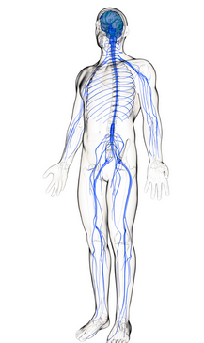

The Learning Approach
This approach argues that all human behaviour is determined by our environment, specifically through learning processes. We are born a ‘tabula rasa’, which means blank slate. We then learn all of our behaviours. This is acquired through 3 main methods:

- Learning via association
- Learning via rewards and punishment
- Learning via observing and imitating

Typically in this approach behaviours studied include gender acquisition, behaviour modification, clinical disorders and criminal behaviour.

How could the following behaviours be explained using Learning Psychology?

- Aggression

- Criminal behaviour

How is Learning Psychology used in adverts?

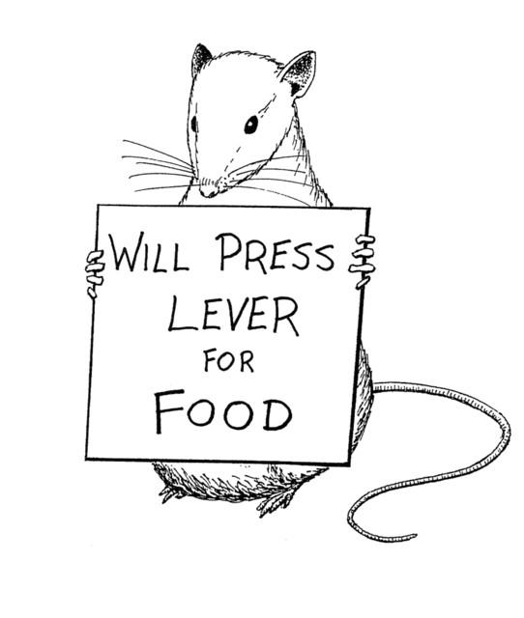

The Social Approach
This approach argues that all human behaviour is determined by our environment, specifically the social situation we are in and others around us. Our behaviour changes based on whether we are with our friends or family members, this is because there are generally different expectations and attitudes from these two social groups. Also the social setting you are in influences your behaviour, so your behaviour may be different at school as opposed to in town shopping. As a consequence there are large differences in behaviours between cultures – for example if you compared the ‘normal’ behaviour of someone living in Britain to the ‘normal’ behaviour of a member of a tribe in Papa New Guinea, there would be large differences in these ‘normal’ behaviours. Typically in this approach behaviours studied include obedience, prejudice and cross cultural differences in behaviour.

How can Social Psychology explain violent behaviour such as football hooliganism?

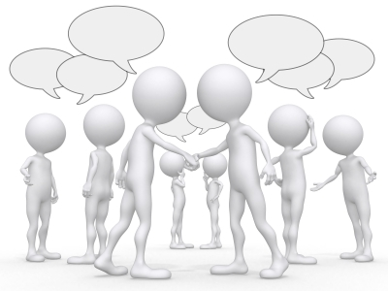

The Cognitive Approach
This approach argues that all human behaviour is determined by the way information is processed from the environment. Behaviour is based on the thought processes we go through and the way information is in interpreted, as well as the information we pay attention to and don’t pay attention to. Typically in this approach behaviours studied include eye witness testimony, clinical disorders, attention, perception and memory.

How can memory influence our behaviour?

How is the cognitive approach used to study eye witness testimony?

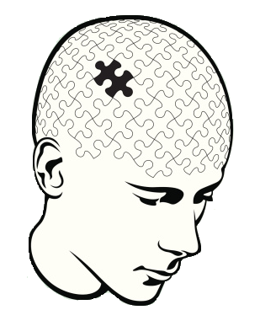

ANNE

Anne has just had her first baby and feels very depressed and is thinking she may not be a good mother. She cannot understand why she feels like this- the baby was very much wanted and she has a loving and supportive husband. Anne had a very unhappy childhood: she was an only child with a mother who was cold and uncaring. Her father left when she was only 4 years old. He tried to keep in touch with her but her mother did her utmost to prevent him. Anne’s best friend has also had a baby, and seems to be coping better than she is.
Use the social approach, the biological approach, the learning approach and cognitive approach to explain why feeling depressed and doubting her abilities of being a mother

Biological Approach  Depression immediately after pregnancy  - May be post-natal depression which is due to hormone levels, a large drop in progesterone and low levels of dopamine and serotonin. | Social Approach  Feels isolated – as her best friend is coping well she may feel so does not fit in with her old social group as she is not coping well.
Cognitive Approach  Faulty thinking – she thinks she is not a good mother and everything she is doing is wrong which is not the case. | Learning Approach  As Anne was unhappy when she was a child and saw her mum as cold and uncaring she may have learned poor mothering styles from her mum.

PSYCHOLOGY - SUMMER HOMEWORK
1. Try and explain the 2 following behaviours using the 4 different approaches. Use the one in class to help you, and the information above. Don’t worry if you get stuck – try as many as you can.
2. Research – below are worksheet on the Social and Cognitive approach – the two approaches to human behaviour we will be starting with in September. Research the approaches and answer the questions accordingly.

MARY

Mary is a 26 year old smoker. She started smoking at the age of 14 when quite a few of her friends did. Soon after this she became quite concerned about her weight (a concern she still has) and used cigarettes as an appetite suppressant. Mary decided at the age of 21 that she no longer wanted to smoke but despite many attempts she has never, in the last 5 years, manage to succeed. Now she has reluctantly given up trying because she thinks she will not succeed.
Use the social approach, the biological approach, the learning approach and cognitive approach to explain why Mary started smoking, why she continued to smoke and why she cannot give up.
Biological Approach | Social Approach
Cognitive Approach | Learning Approach

LEWIS
Lewis is 15 years old and regularly ‘skives’ school with his friends in order to go to a local gym and box. Even though he is quite small in build, his ambition is to be a professional boxer and is now becoming more aggressive as he trains more. Lewis is not interested in any of the usual things that lads his age enjoy- not music, nor computer games, nor girls. He certainly is not interested in gaining qualifications and thinks they are totally pointless. He has never been successful in academic work and recently has been placed in the ‘bottom’ group in every school subject for which there is a banding system.

Use the social approach, the biological approach, the learning approach and cognitive approach to explain why Lewis skives school, why he boxes and why he is not interested in education.
Biological Approach | Social Approach
Cognitive Approach | Learning Approach

SOCIAL PSYCHOLOGY
Define the following terms:

Obedience

Blind Obedience

Destructive Obedience

Legitimate authority figure

Now apply the above terms to explain Nazi Soldiers behaviour in WWII
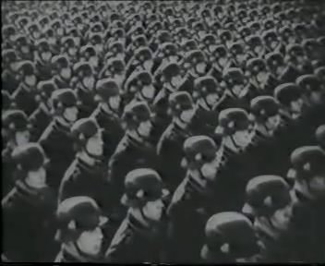

Based on your answer above, do you think there anything that could have been done to change/stop the Nazi Germany solider behaviour during WWII?

Research Soloman Asch’s study on conformity – What did he do? what did he find?

Research Philip Zimbardo’s Stanford prison experiment – What did he do? What did he find?

Sampling

Psychology is a research based subject, and to conduct research we need people to take part in this research, these people are called participants. When deciding how to recruit participants to studies, Psychologists can use a range of methods called sampling techniques.

In order to conduct any research we need some people (or animals) to study. The participants which are to be used are called a sample. To obtain a sample researchers must first identify the target population. This is the whole group with which the study is concerned, for example, a study on "the attitudes of college students towards smoking" would have a target population of "all college students". Therefore a sample is smaller group selected from your target population.
The aim is to try and obtain a representative sample and to try to avoid using a biased sample; biased means 'not representative'. For a sample to be representative it needs to be a true reflection of your target population. For example if your target population is 100 psychology students. Consisting of 60 girls and 40 boys, for your sample to be representative your sample needs to consist of 60% girls and 40% boys. (However, as you go through your psychology course, you will not find it difficult to provide examples of very biased samples of participants being used).
How many participants should be used?
This depends on several factors. The size of the target population is important. If the target population is very large (for example. all 4-6 year olds in Britain) then you need a fairly large sample in order to be representative. If the target population is much smaller, then the sample can be smaller but still be representative. The rule is: there must be enough participants to make the sample representative of the target population but the sample must not be so large that the study takes too long or is too expensive.
1. What is the target population in the following studies?

a. A study of attitudes of Tory voters to NHS reforms.

.....................................................................................................................

b. An experiment to investigate the effects of separation in infant monkeys.

.....................................................................................................................

d. A study of prejudice among South African whites.

.....................................................................................................................

e. Research into the use of specially adapted cookers by blind people.

.....................................................................................................................
When looking for a sample, the researcher is aiming to gain population validity.

What is population validity?

Research the below sampling techniques and define these – explaining how a psychologist would use them.
RANDOM SAMPLE

Limited Researcher Bias
- The researcher has no choice over who is chosen, as everyone is randomly selected so everyone in the target population has an equal chance of being chosen.
- Therefore, the sample is not open to bias and is likely to be representative so can be generalised to the target population.

Unrepresentative sample
- Cannot be certain the sample is representative. It is difficult to ensure everyone in the target population is included in the sample, for example the researcher may randomly select all males in the sample.
- Therefore, the sample is unrepresentative, and lacks population validity.

Time consuming
- It can take a long time to create a sample, as first you need to get a list of everyone in the target population. Furthermore, you may not be able to get a list of everyone in the target population, and small minority groups may not be included.
- Therefore, this is not a practical sampling method and may not be representative of the target population, so you cannot generalise findings.

OPPORTUNITY SAMPLE

Quick and easy method
- Allows large numbers of participants to be recruited quickly and easily as participants who are readily available are recruited.
- Therefore, this a more pratical method to use compared to other methods such as stratified.

Ethical
- The researcher can judge if the potential participant looks too busy to take part in researcher, and thus not ask them to take part.
- Therefore, the needs of the potential participant are being considered and research is not being thrust upon them

Biased sample
- The researcher picks who they ask to take part so may be bias in who they choose, and the sample will only include those who were around at the time the research was being conducted, so could all share similar characteristics eg psychology students.
- Therefore, the sample will be unrepresentative and cannot be generalised to the target population.

VOLUNTEER SAMPLE

Practical
- Good to use when the target population is hard to find, for example people who think they have been abducted by aliens, as the researcher can place an advert and the participants comes to the researcher rather than the researcher seeking them out.
- Therefore, this is a practical method to use.

Ethical
- As participants contact the researcher themselves, they select themselves to take part, as opposed to the researcher selecting them (unlike an opportunity sample)
- Therefore, participants give their consent to take part in the research

Bias sample
- You can get a certain type of person who volunteers to participate in research. Normally they are more motivated to do well.
- Therefore, the sample can be bias and unrepresentative of the target population and so cannot be generalised to the target population.
SYSTEMATIC SAMPLE

Limited Researcher Bias
- The researcher has no choice over who is chosen, as everyone selected will be every nth person
- Therefore, the sample is not open to bias and should be spread evenly across the population so is likely to be representative so can be generalised to the target population.

Unrepresentative sample
- Cannot be certain the sample is representative. It is difficult to ensure everyone in the target population is included in the sample, the systematic basis may not allow for subgroups within the population to be captured, for example every nth person may end up being all Asian people, with other ethnicity not represented.
- Therefore, the sample is unrepresentative, and cannot be generalised to the target population.

Time consuming
- It can take a long time to create a sample, as first you need to get a list of everyone in the target population. Furthermore, you may not be able to get a list of everyone in the target population, and small minority groups may not be included.
- Therefore, this is not a practical sampling method and may not be representative of the target population, so you cannot generalise findings.

STARTFIED SAMPLE

Representative sample
- As the population is divided into subgroups, and randomly picked within each subgroup all relevant groups within your target population will have been represented in the sample.
- Therefore the sample should be representative so findings can be generalised to the target population.

Time consuming
- It can take a long time to create a sample, as first you need to get a list of everyone in the target population and all the required groups needed to make a representative sample.
- Therefore, this is can take a very long time and thus it is not a practical method.

COGNITIVE PSYCHOLOGY

Define the following terms
Memory

Forgetting

Research the memory case of Clive Wearing.

What happened to him?

What does his case study tell us about memory?

Research the memory case of HM (Henry Molaison)
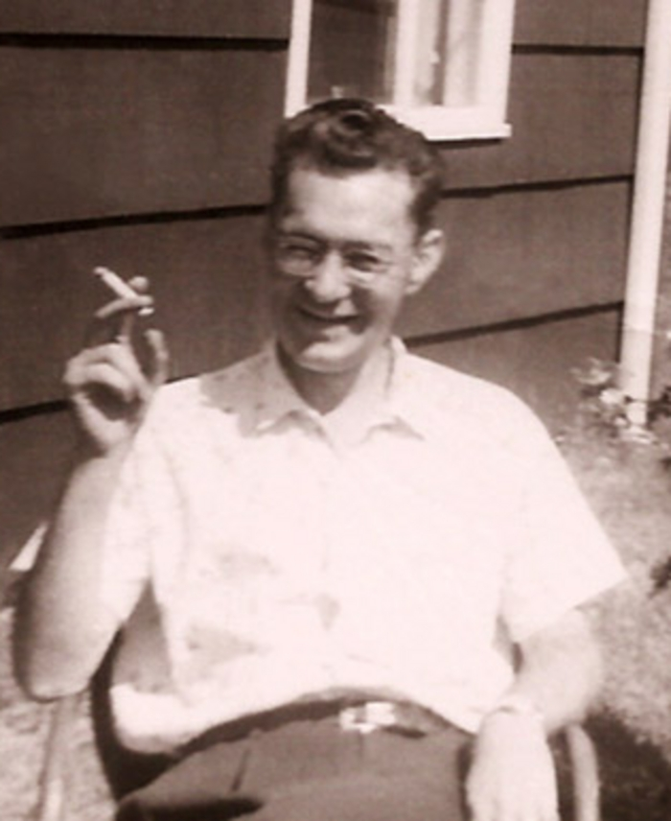
What happened to him?

What does his case study tell us about memory?

Research the following terms – in relation to psychology – what do they mean?
Validity

Internal Validity

External Validity

Ecological Validity

Mundane Realism

Demand Characteristics

Reliability

Extraneous Variable

Independent Variables

Dependent Variable

