Task One:
Label the skeleton:
You need to label the skeleton with the following bones:
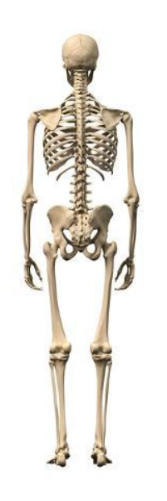
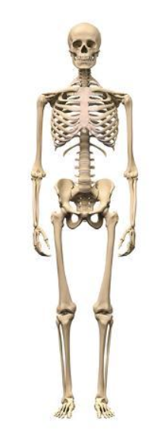
Cranium, mandible, atlas and axis in the neck, sternum, clavicle, scapula, ribs, vertebral column, ilium, pubis, humerus, radius, ulna, femur, patella, tibia, fibula, calcaneus, talus, tarsal, metatarsals, phalanges, carpals, metacarpals, phalanges.

