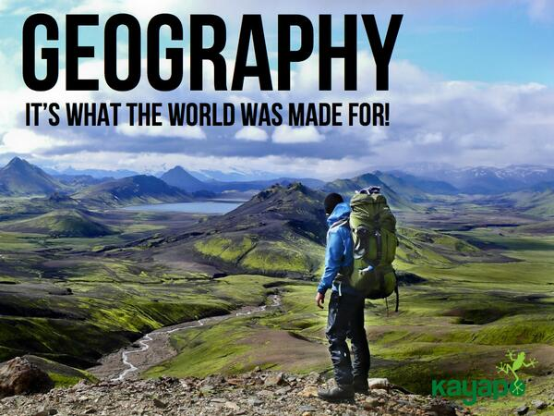

Welcome to A level Geography

at

The West Bridgford School

geography@wbs.school
@WBSGeogratweets

General Resources

Exam Board Student Pages: http://www.aqa.org.uk/subjects/geography/as-and-a-level

BBC Bitesize: http://www.bbc.co.uk/schools/gcsebitesize/geography/

S-Cool Geography Revision: http://www.s-cool.co.uk/a-level/geography

There are several Student Textbooks available. We will have several of each in school for your use however if you would like your own these are the details you will need to find them:

AQA Geography A level and AS: Physical Geography. Oxford Publishers ISBN 978-0-19-836654-5
AQA Geography A level and AS: Human Geography. Oxford Publishers ISBN 978-0-19-836654-6

Task: Geography in the news journal

The Geography AS course is very ‘current events’ based, so it is important that you watch, listen to, read or search the news at least a few times a week. You can get the news in a variety of ways and should choose a method that suits you the best:
- TV: Almost every channel has its own news programme and news is broadcast at a variety of times, morning, lunchtime and evening.
- Newspapers: A variety exist – the best for our course are the so-called broadsheets (The Guardian, The Independent, The Times, The Telegraph or the FT). However, a good one to read is The ‘I’ newspaper as it is a shorter more accessible version of The Independent and only costs 20p.
- Radio: Almost every station broadcasts the news at regular intervals, though these are often short overviews rather than full in-depth reports.
- Internet: Great for browsing and for searching for particular news stories. You can also compare the reporting of a story from different perspectives very easily. There are also news apps that can be downloaded to computers or Smart phones.

The task:
Pick one relevant news story each week and write a report on the geography of the story.
Instructions:
1. Watch, listen, read or search the news.
2. Pick a RELEVANT news story to our course. It should fit into one (or more) of these categories:
• Natural disaster (Flood, drought, forest fire, storm, hurricane, typhoon, volcano, earthquake, mud/land slide, tsunami)
• Climate change/global warming
• Trade (particularly global)
• Britain’s ageing population
• Migration (particularly EU immigration)

A great place to start is the BBC News website (http://www.bbc.co.uk/news/) as it covers news in depth and breadth. Use the search box at the top to search for key terms and narrow down the search.

See below for a modelled example of how to write your report.
Over the eight weeks, try to cover all the categories bullet pointed above.
Create a collage of relevant geographical news stories that you have cut out from a newspaper or printed headlines from the internet.

EXAMPLE!
HEADLINE/NEWS STORY: “Climate Change helps seas discover Japanese war dead”
➔ From BBC News, 7th June 2014.
What is the LOCATION of the event?
The Marshall Islands are in the Pacific Ocean, to the North East of Papua New Guinea. They are a series of islands that are part of the wider region, Micronesia. The islands are found north of the Equator.
The population is approx. 70,000 (2009) and the GDP/capita is $2,900 making it one of the poorest nations in the world.

What are the key ideas or events that have taken place? (Think about What, Who, When and Why?)
- Rising sea levels have disturbed the skeletons of soldiers killed during WW2.
- Water is also threatening to destroy sea defences and roads.
- Salt from the sea water is also making land infertile.
- Communities are flooded frequently, particularly during high spring tides.
What were the causes of the event?
- Sea levels are rising at a rate of 12mm/year.
- This is much faster than other places in the world.
- Sea levels are rising due to global warming, caused by human activities which put CO2 into the atmosphere.
- United Nations is yet to agree on a deal to reduce CO2 emissions at the National level, mainly because emerging economies (China, India) want the developed nations (e.g. USA and UK) to take more of the responsibility.
What were the impacts or effects? (Be specific – where, what, who, how many?)
- 26 bodies have been washed from their graves.
- If roads are washed away, people will struggle to move from place to place. This might affect business and tourism.
- If land is made infertile, people will struggle to grow crops. This might lead to famine.
- If the sea defences are destroyed, communities will be flooded more frequently.
What is your opinion of the event? Why did you choose it? How does it make you feel?
I chose this article because it has a creepy element to it – imagine walking along a beautiful white sandy beach and stumbling across a body! However, there is actually a really serious message in the article about how our overuse of fossil fuels is having a serious and devastating effect on people on the other side of the world.
I think that this is THE biggest challenge for our planet and the UN needs to negotiate a deal on carbon emissions ASAP. Without a slowing of global warming, places like the Marshall Islands will disappear under the waves completely within the next 50-100 years.
While I can understand that China and India have the right to industrial development, more should be done to encourage these massive nations to use green and eco-friendly methods of energy production.
http://www.bbc.co.uk/news/science-environment-27742957

Week beginning:
HEADLINE/NEWS STORY:
What is the LOCATION of the event?

What are the key ideas or events that have taken place? (Think about What, Who, When and Why?)

What were the causes of the event?

What were the impacts or effects? (Be specific – where, what, who, how many?)

What is your opinion of the event? Why did you choose it? How does it make you feel?

Week beginning:
HEADLINE/NEWS STORY:
What is the LOCATION of the event?

What are the key ideas or events that have taken place? (Think about What, Who, When and Why?)

What were the causes of the event?

What were the impacts or effects? (Be specific – where, what, who, how many?)

What is your opinion of the event? Why did you choose it? How does it make you feel?

Week beginning:
HEADLINE/NEWS STORY:
What is the LOCATION of the event?

What are the key ideas or events that have taken place? (Think about What, Who, When and Why?)

What were the causes of the event?

What were the impacts or effects? (Be specific – where, what, who, how many?)

What is your opinion of the event? Why did you choose it? How does it make you feel?

Week beginning:
HEADLINE/NEWS STORY:
What is the LOCATION of the event?

What are the key ideas or events that have taken place? (Think about What, Who, When and Why?)

What were the causes of the event?

What were the impacts or effects? (Be specific – where, what, who, how many?)

What is your opinion of the event? Why did you choose it? How does it make you feel?

Week beginning:
HEADLINE/NEWS STORY:
What is the LOCATION of the event?

What are the key ideas or events that have taken place? (Think about What, Who, When and Why?)

What were the causes of the event?

What were the impacts or effects? (Be specific – where, what, who, how many?)

What is your opinion of the event? Why did you choose it? How does it make you feel?

Week beginning:
HEADLINE/NEWS STORY:
What is the LOCATION of the event?

What are the key ideas or events that have taken place? (Think about What, Who, When and Why?)

What were the causes of the event?

What were the impacts or effects? (Be specific – where, what, who, how many?)

What is your opinion of the event? Why did you choose it? How does it make you feel?

