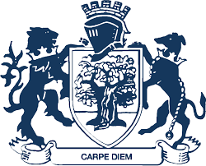
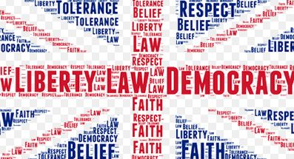
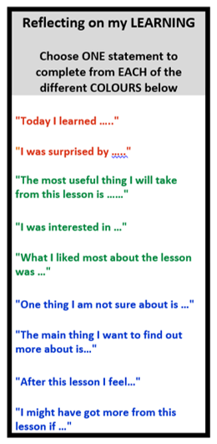
Key Assessment 2:
County Lines
Enrichment in Year 11 PSHE

My Future Pathways Event
Post-16 Education Talk
Mock Interviews
Post 16 provider events
THINK BIG careers in tech
Personal Safety-Nightlife
Healthy relationships
The World of Finance
Health and Wellbeing
Year 10
Key Assessment 1:
Infertility and IVF

YEAR
12
Living as a trans person
Contraception
What are employers looking for?
- To engage with content and a careers programme that supports the transition from year 11 to post-16 pathways.
- To develop skills around emotional literacy to discuss challenging and potentially emotive topics.
- To understand key societal challenges that face young people today.
Key Skills: • Future planning • Evaluation • Tolerance • Challenge

- Post-16 Education
- Sixth Form
- College
- Apprenticeship
Labour Market Information
The Role of a Union
Reflecting on your careers journey
Careers Challenge
Safety while travelling
County Lines/Gangs
What are the aims of Year 11 PSHE?
Year 11 PSHE
Health and Wellbeing
Careers
Interview Techniques
Job Applications
Citizenship
Key Assessment 3: LMI Project
Part-Time Work Under 18
Careers
Revision strategies
Rotation 3
Careers
Dealing with exam pressure
Forced Marriage
Criminal Exploitation
Citizenship and the Law
Gangs/Knife Crime
Drug Awareness
Female Genital Mutiliation
Infertility and IVF
HIV and Aids
STIs
Criminal Justice System
Radicalisation
LGBTQ+/Gender Identity
Rotation 2
RSE
RSE
Women’s rights
Jobs – preparing for interviews
Youth Homelessness
Year 11
What came before?
Rotation 1

