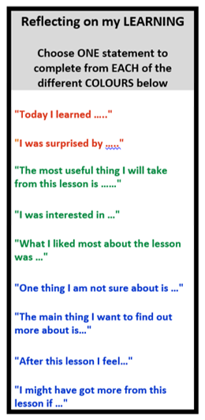
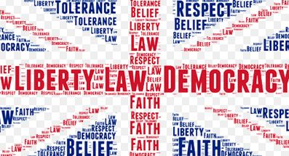

Interviews
Managing a professional online presence
Charities and support organisations
Capital Punishment
Radicalisation and Extremism
Health and Wellbeing
Financially motivated sexual extortion
LGBTQ+ Rights
Enrichment in Year 10 PSHE

Broxtowe Youth Homelessness
ASK apprenticeships
THINK BIG careers in tech
Fantasy vs Reality
Cosmetic and Aesthetic Procedures
Key Assessment 1:
Letter to the Editor

Key Assessment 3: Statutory and Voluntary Support Organisations
Key Assessment 2: Knife Crime
Character Education
Personal Safety
YEAR
11
Health and Wellbeing
Independent Living
Youth Homelessness
Gang Activity
Citizenship and the Law
Gun and Knife Crime
Criminal Justice System
Pregnancy/
Contraception
Domestic Abuse and Coercive Relationships
Year 9
- To build and develop empathy through exploration of broad areas of citizenship to develop individuals’ perspective on issues.
- To develop practical skills in relation to careers education.
- To enhance knowledge of RSHE by developing broader conversations on topics that can impact relationships.
- To start to understand the pathways that they can take after leaving secondary school education.
Year 10 PSHE
What are the aims of Year 10 PSHE?
Pornography
Jobs Research
Apprenticeships vs. Higher Education
Careers
Volunteering and Charity Work
Protecting your data and identity
Citizenship
Crime Awareness: local area
Hate Crime
Careers
Equality in the workplace
RSE
RSE
Gender Identity
Misogyny
STIs
Sexual Exploitation
Radicalisation and Extremism
Politics and Elections
Emotional Health
Drugs
County Lines and Exploitation
- Relationships and Sex Education
- Drug Awareness
- Citizenship
- Careers
Year 10
What came before?
Women’s Rights and Abortion
Key Skills: • Reflection • Evaluation • Tolerance • Debate

Rotation 3
Rotation 2
Rotation 1

