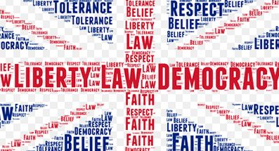
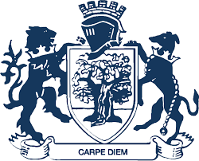
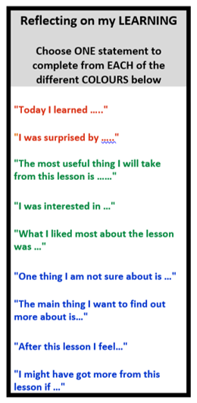
Solve a problem by designing a product
Careers
Citizenship
Laws and their importance
Addiction
Self-harm and eating disorders
Key Assessment 3: Refugees and Asylum Seekers – Newspaper Article
Key Assessment 1: Healthy relationships leaflet
Key Assessment 2: Drugs Presentations
- To develop a broad understanding of what it means to be a citizen in an ever-changing landscape and how to adapt to that.
- To develop the emotional literacy to talk about challenging topics and open up a conversation around signposting and support.
- To support the options process to ensure a smooth transition into GCSE learners.
Ice Breaker
Immigration including refugees and asylum seekers
Globalisation and the environment
Building Resilience and Emotional Health
Cannabis Debate
Intro to County Lines
Substances
Key Skills: • Challenging • Verbalising • Evaluating • Reflecting
YEAR
10
Healthy/
Unhealthy Relationships
- Hate Crime
- Gun and Knife Crime
- Homelessness
- Independent Living
- Fantasy v Reality
- Cosmetic and Aesthetic Surgery
- Domestic Abuse
Enrichment in Year 9 PSHE
Year 9 Options Day
Year 9 Enterprise Day
Year 9 STEM Day
Female Genital Mutilation
Drugs and the Law
Year 9 PSHE
What are the aims of Year 9 PSHE?
Drugs and the Effects
Drugs Information
Prevent: Radicalisation and Extremism
Careers Work
Addiction (gambling and tech)
Force-Marriage and Honour-Based Abuse
Child Sexual Exploitation
Pregnancy and Choices
STIs including HIV
Relationships and Sex Education
Contraception
Smoking Letter
Youth Produced Sexual Imagery and the Law
Puberty
Human Rights
First Aid
Healthy Lifestyles
Animal Welfare
Politics and Elections
Rotation 3
Rotation 2
Rotation 1
What came before?
Year 8
Year 9

