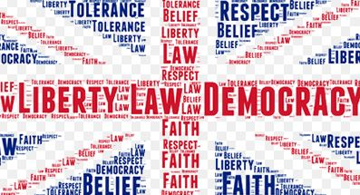
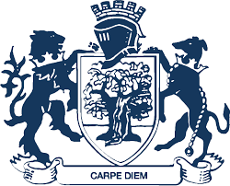
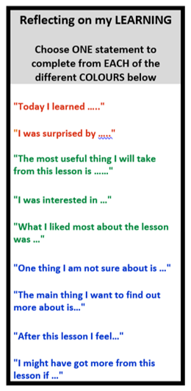
Smoking, vaping and the law
Gender Identity and Sexuality
Puberty
Human Rights
Key Assessment 3: Smoking Letter
Key Assessment 2: First Aid Test
Defibrillator
Use
Recovery Position
Choking
Year 7
YEAR
9
Binge Drinking Awareness
First Aid
Citizenship
Enrichment in Year 8 PSHE

Step into the NHS Careers Competition
World Book Day Work
Emotional Health and Wellbeing Week
Think CAREers workshop

Key Assessment 1:
Online Media Project
Heavy Bleeding
Health and Wellbeing
Key Skills: • Reflection • Evaluation • Tolerance • Debate

What are the aims of Year 8 PSHE?
Year 8 PSHE
Animal Rights
Substances
Personal Safety/Hygiene
Health and Wellbeing
Online World vs Reality - Pornography
What does it mean to have an identity?
- To understand key aspects of healthy lifestyles, including relationships.
- To develop an understanding of how puberty, consent and Youth-produced Sexual Imagery can have an impact on individuals.
- To develop first aid skills and reflect on how these will help individuals to be well-rounded and skilled individuals.
- To understand their rights and responsibilities as young people and how these develop as they go through life, including the law around young people.

Legal Scenarios
Year 8
What came before?
Allergies
Burns
What is a community?
CPR
Minor Cuts/Grazes
Consent and Sexual Harassment
Animal Welfare
Financial Responsibilities
Careers and Employability
Hate Crime
The Law: Under 16
Careers
Careers and Employability
British Values
Anti-Bullying
Diversity
Settling In
Dementia
Communities
Youth-Produced Sexual Imagery and the law
RSE
Healthy Relationships
- Relationships and Sex Education
- Drug Awareness
- Citizenship
- Careers
Mental Health
Healthy lifestyles
Health and Wellbeing
Rotation 3
Rotation 2
Rotation 1

