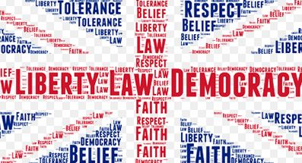
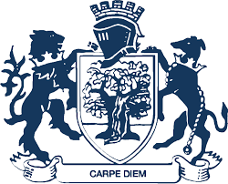
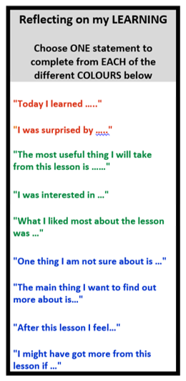
Key Assessment 3: Diversity Research and Presentations
Health Education
Diversity
Anti-Bullying
Health and Wellbeing
Embracing Diversity
Personal Hygiene
Summer Term
Key Assessment 2:
Anti-Bullying Poster
Icebreaker Evening
Year 7 PSHE
What are the aims of Year 7 PSHE?
Getting to know your tutor group and tutors
Year 6 Transition Day PSHE lesson
- Healthy Lifestyles
- Emotional Health and Wellbeing
- First Aid
- Human Rights
- Animal Welfare
- Smoking and the law
- Binge Drinking Awareness
Road,
Cycle and Firework Safety
Health and Wellbeing
Introduction to Careers
Dragon’s Den business pitch
Careers
Online Safety
Emotional Health and Wellbeing
Bystander Initiative
Diversity
Disability Awareness
Citizenship
Anti-Bullying Alliance Work
British Values and Citizenship
Emotional Health and Wellbeing
School Community and Ethos
Key Assessment 1:
All About Me Poster
Letter to Self
Water Safety
Sun Safety
Citizenship
Looking to the Future
Puberty
Team Building
What came before?
Year 7
Year 6
- To support the transition from primary to secondary school.
- To aid the settling-in process to secondary school including new boundaries, routines and expectations.
- To develop an understanding of the school’s core values and ethos.
Key Skills: • Building Relationships • Reflecting • Questioning

Braille and Sign Language
Settling in at WBS
Enrichment in Year 7 PSHE

Healthy Body, Healthy Mind Day
Anti-Bullying Production
Road safety workshop
YEAR
8
Spring Term
Autumn Term

