French @ WBS Year 13 Roadmap
Subject Aim: The second year of A level study encourages students to become more analytical thinkers who are able to evaluate and discuss.
The 2 themes of Social Issues and Trends and Political and Artistic Culture continue but are more multicultural and political in nature.
During the Autumn term you will study a second literary work – this time a book or a play.
In addition, you will start preparing an IRP for your speaking exam.
You will be using the OUP course and the associated Kerboodle package.
Grammar is consolidated throughout and more advanced points covered.
 | TOPIC 1 Les aspects positifs d’une  société diverse | ASSESSMENT IN YEAR 13
AUTUMN TERM | The benefits of living in an ethnically diverse society in the French-speaking world; the need for tolerance and respect in society; promoting diversity to create a richer world. | There will be 6 Key Assessments and 2 mock exams in Year 13.  Assessments will be set upon completion of each module and will test a variety of skills.
AUTUMN TERM | TOPIC 2 Quelle vie pour les  marginalisés | HOMEWORK IN YEAR 13
SPRING TERM | Different groups who are socially marginalised in the French-speaking world; measures to help people who are marginalised; contrasting attitudes to people who are marginalised. | Homework is used to consolidate and expand upon work done in the classroom. A variety of tasks will be set.
SPRING TERM | TOPIC 3 Comment on traite les  criminels | REVISION FOR ASSESSMENTS IN YEAR 13
SUMMER TERM | Different attitudes to crime throughout the francophone world; the prison system – its merits and problems; alternative forms of punishment. | Reminders of assessments will be set on Classcharts. Each assessment tests accumulated linguistic and factual knowledge.
SUMMER TERM | TOPIC 4 Les ados, le droit de vote et  l’engagement politique | ENRICHMENT THEMES IN YEAR 13
SUMMER TERM | The French political system and its evolution; lowering the voting age to 16; political engagement of young French people; the future of politics. | The whole of the A level course provides enrichment to the students through the study of artistic, social and political themes.  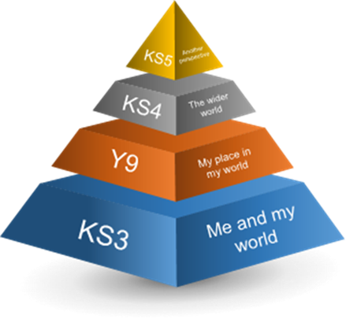
SUMMER TERM | TOPIC 5 Manifestations, grèves – à qui  le pouvoir ?
SUMMER TERM | The role of unions; strikes and protests; different attitudes towards strikes, protests and political tension in France.
SUMMER TERM | TOPIC 6 La politique et l’immigration
SUMMER TERM | Immigration in francophone countries; the viewpoints of different political parties regarding immigration; the life of an immigrant; racism.

