French @ WBS Year 12 Roadmap
Subject Aim: The Year 12 French A level course builds on knowledge acquired at GCSE level but you will be encouraged to see the world from a broader perspective.
There are 2 themes covered: Social Issues and Trends and Political and artistic culture.
In the Spring term you will also start studying the literature component of the course in the form of a film. You will be using the OUP course and the associated Kerboodle package.
Grammar is consolidated throughout and more advanced points are covered.
 | TOPIC 1 La famille en voie de  changement | ASSESSMENT IN YEAR 12
AUTUMN TERM | Trends in marriage and in other forms of partnerships; the merits and problems of different family structures; inter-generational relationships and the problems which can arise. | There will be 6 Key assessments plus a mock exam in Year 12. Assessments will be set upon completion of each module and will test a variety of skills.  The mock will be an AS Paper 1 which will assess listening, reading, translation and summarising skills.
AUTUMN TERM | TOPIC 2 La <<cyber-société>> | HOMEWORK IN YEAR 12
 | How technology has transformed everyday life; the dangers of digital technology; the different users of digital technology and future developments. | Homework is used to consolidate and expand upon work done in the classroom. A variety of tasks will be set.
 | TOPIC 3 Le rôle du bénévolat | REVISION FOR ASSESSMENTS IN YEAR 12
SPRING TERM SUMMER TERM | The voluntary sector in France; the beneficiaries of voluntary work; the benefits of voluntary work for the volunteers and society as a whole. | Reminders of assessments will be set on Classcharts. Each assessment tests accumulated linguistic and factual knowledge.
SPRING TERM SUMMER TERM | TOPIC 4 Une culture fière de son  patrimonie | ENRICHMENT THEMES IN YEAR 12
SPRING TERM SUMMER TERM | The notion of heritage on a regional and national scale in France; famous French heritage sites; how heritage impacts upon and reflects the national culture. | 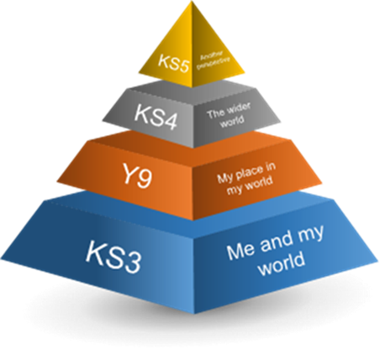  The whole of the A level course provides enrichment to the students through the study of artistic, social and political themes.
SPRING TERM SUMMER TERM | TOPIC 5 La musique francophone  contemporaine
SPRING TERM SUMMER TERM | The popularity of contemporary francophone music; diversity of musical genres and styles; the listeners; how to safeguard francophone music.
SPRING TERM SUMMER TERM | TOPIC 6 Le septième art
SPRING TERM SUMMER TERM | French cinema; the evolution of French cinema; the continuing popularity of French cinema and film festivals.
Where Next?
In Year 13 you will expand your knowledge by studying themes of global importance. You will study a book or a play and develop your analytical skills.

