Spanish @ WBS Year 13 Roadmap
Subject Aim: The second year of A level study encourages students to become more analytical thinkers who are able to evaluate and discuss.
The 2 themes of Social Issues and Trends and Political and Artistic Culture continue but are more multicultural and political in nature.
During the Autumn term you will study a second literary work – this time a book or a play.
In addition, you will start preparing an IRP for your speaking exam.
You will be using the OUP course and the associated Kerboodle package.
Grammar is consolidated throughout and more advanced points covered.
 | TOPIC1 La immigration | ASSESSMENT IN YEAR 13
AUTUMN | Positive and negative aspects of immigration; immigration in the Spanish-speaking world; the problems faced by illegal migrants.  KA1: Mod 1 Autumn half term 1 ________ | There will be 6 Key Assessments and 2 mock exams in Year 13.  Assessments will be set upon completion of each module and will test a variety of skills.
AUTUMN | TOPIC 2 El racismo | HOMEWORK IN YEAR 13
TERM | Racist and xenophobic attitudes in the Spanish-speaking world; measures to combat racism and their effectiveness; existing and possible new legislation against racism.  KA2: Mod 2 Autumn half term 2 ________ | Homework is used to consolidate and expand upon work done in the classroom. A variety of tasks will be set.
TERM | TOPIC 3 La covivencia | REVISION FOR ASSESSMENTS IN YEAR 13
SPRING TERM SUMMER TERM | The different ways cultures integrate in Hispanic society; integration of different cultures within the sphere of education; the co-existence of various religions in the Hispanic world.  KA3: Mod 3 Autumn half term 2 ________ | Reminders of assessments will be set on ClassCharts.  Each assessment tests accumulated linguistic and factual knowledge.
SPRING TERM SUMMER TERM | TOPIC 4 Jóvenes de hoy,  ciudadanos de del mañana | ENRICHMENT THEMES IN YEAR 13
SPRING TERM SUMMER TERM | The importance of politics in young people’s lives; changing attitudes to politics; unemployment among young people; the society young people in the Hispanic world wish to live in.  KA4: Mod 4 Spring half term 1 ________ | The whole of the A level course provides enrichment to the students through the study of artistic, social and political themes.  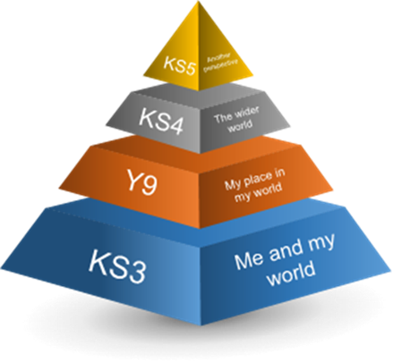
SPRING TERM SUMMER TERM | TOPIC 5 Monarquías y dictaduras
SPRING TERM SUMMER TERM | The impact of the civil war and Franco’s dictatorship; the transitions from monarchy and republic to dictatorship and back to monarchy; dictatorships in Latin America.  KA5: Mod 5 Spring half term 2 ________
SPRING TERM SUMMER TERM | TOPIC 6 Los movimientos populares
SPRING TERM SUMMER TERM | Effective strikes and protests; the power of trade unions; the 15-M Movement in Spain and the Mothers of the Plaza de Mayo in Argentina.  KA6: Mod 6 Summer half term 1 ________

