Spanish @ WBS Year 12 Roadmap
Subject Aim: The Year 12 Spanish A level course builds on knowledge acquired at GCSE level but you will be encouraged to see the world from a broader perspective. There are 2 themes covered: Social Issues and Trends and Political and artistic culture.
In the Spring term you will also start studying the literature component of the course in the form of a film. You will be using the OUP course and the associated Kerboodle package.
Grammar is consolidated throughout and more advanced points are covered.
 | TOPIC 1 Los valores tradicionales y  modernos | ASSESSMENT IN YEAR 12
AUTUMN TERM | The various types of 21st century Spanish family; trends in marriage; modern and traditional values; divorce in Span; the religious history of Spain and the influence of the church.  KA1: Mod 1 Autumn half term 1 ________ | There will be 6 Key assessments plus a mock exam in Year 12. Assessments will be set upon completion of each module and will test a variety of skills.  The mock will be an AS Paper 1, which will assess listening, reading, translation and summarising skills.
AUTUMN TERM | TOPIC 2 El ciberespacio | HOMEWORK IN YEAR 12
 | The positive and negative influences of the internet; smartphones; the influence of social networks on Hispanic society.  KA2: Mod 2 Autumn half term 1 ________ | Homework is used to consolidate and expand upon work done in the classroom. A variety of tasks will be set.
 | TOPIC 3 La iguldad de los sexos | REVISION FOR ASSESSMENTS IN YEAR 12
SPRING TERM SUMMER TERM | Women in the world of work and at home; male chauvinism; feminism; LGBT rights; gay marriage in Spain and the Hispanic world.  KA3: Mod 3 Autumn half term 2 ________ | Reminders of assessments will be set on ClassCharts. Each assessment tests accumulated linguistic and factual knowledge.
SPRING TERM SUMMER TERM | TOPIC 4 La influencia de los ídolos | ENRICHMENT THEMES IN YEAR 12
SPRING TERM SUMMER TERM | The positive and negative influence musicians have on people; the effect of TV and film stars in society; young fashion models.  KA4: Mod 4 Autumn half term 2 ________ | The whole of the A level course provides enrichment to the students through the study of artistic, social and political themes.  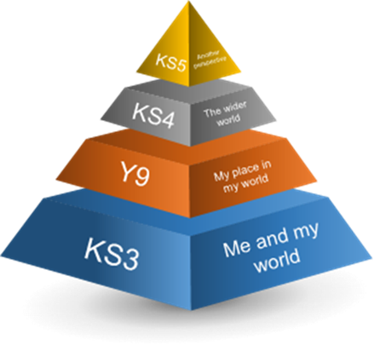
SPRING TERM SUMMER TERM | TOPIC 5 La identidad regional en España
SPRING TERM SUMMER TERM | Spanish customs and traditions; gastronomy in Spain; the different languages spoken in Spain and the issues surrounding them.  KA5: Mod 5 Spring half term 2 ________
SPRING TERM SUMMER TERM | TOPIC 6 El patrimonio cultural
SPRING TERM SUMMER TERM | The civilisations which contributed to the cultural heritage of Spain; Spanish and Latin American artists; Spanish architecture; the diversity of Hispanic music and dance.  KA6: Mod 6 Spring half term 2 ________
Where Next? In Year 13 you will expand your knowledge by studying themes of global importance. You will study a book or a play and develop your analytical skills.

