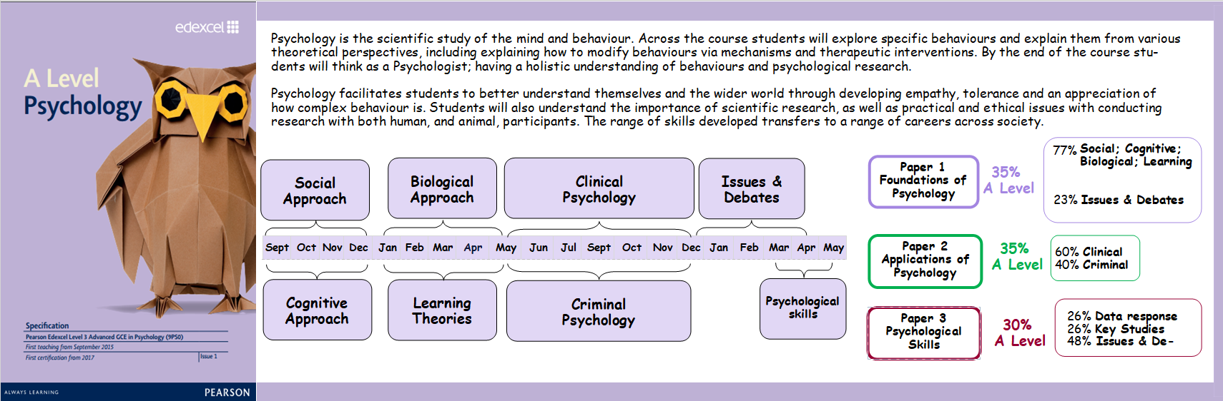

Social Psychology | Biological Psychology | Clinical Psychology | Issues and Debates | A Level Exams
How behaviour is shaped by our culture, society, situation and interactions with others; with a focus on explaining obedient and prejudice behaviour. Ethical guidelines for research will be studied and self-report research methods with you conducting your own questionnaire to investigate prejudice attitudes. | How behaviour is shaped by our biology: genes, nervous system, hormones and the brain with a focus on aggressive behaviour. Scientific methods, family studies and brain scanning techniques will be studied with you conducting own correlational piece of research on aggressive behaviour. | Explaining different explanations of the development and treatment of mental health issues, with a focus on Schizophrenia and OCD. How psychologists make diagnosis and the issues with these techniques. Content analysis will be studied, including thematic analysis with you conducting your own content analysis on the perception of mental health in society. | Using all theories and evidence from the past 2 years you will critically approach a range of issues and debates in order to develop a general knowledge of key issues  and debates within psychology. This will develop your holistic view of behaviour and psychological intervention. | Each exam will cover content covered throughout the approach, including stimulus and data response, short-answer and extended response questions. (Questions marks range from 1 mark question to 20 mark questions)  Key assessments  The aim of these are for you to practice your revision techniques, practice timing of answers, practice exam technique and to get feedback on your exam practice. The key to assessment is to revise thoroughly, but to reflect on your assessment to track and improve your performance in exams. This is why peer assessment will be used as a learning strategy.
Cognitive Psychology | Learning Theories | Criminal Psychology | Psychological Skills
How behaviour is shaped by cognition: the way we process information around us. A focus on explaining memory, memory differences, memory deficits and how this develops as the brain ages. The experimental method and case study research methods will be studied with you conducting your own experiment to investigate memory. | How behaviour is shaped by learning from our environment, particularly through observation and imitation, conditioning, stimulus response and reward and punishment. The observational research method will be studied, as well as animal research with you conducting your own observation on gender differences in behaviour. | Explaining the different definitions and causes of criminal and anti-social behaviour, including the identification and treatment of offenders undertaken by forensic investigators. You will look at what impacts judicial decision making. The experimental method and ethical questioning techniques will be studied with you conducting your own experiment to investigate judicial decision making. | This is a synoptic section in which you will be asked to draw on the past 2 years to review, practice and explain conceptual and methodological issues of conducting research and practising as a psychologist.

olo

