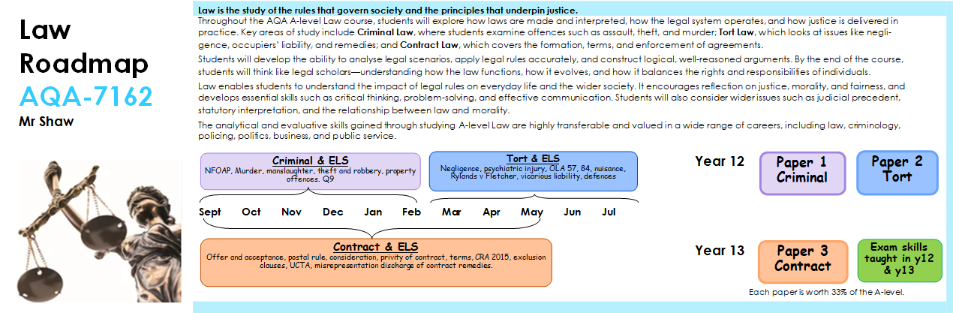
Criminal-General Elements | Non-Fatal Offences | Fatal Offences | Property Offences | Criminal Defences
Covers the foundations of criminal responsibility, including *actus reus* (the physical act), *mens rea* (the mental intent), causation, and strict liability offences. Students learn how these elements must be proven for a conviction. | Focuses on offences such as assault, battery, ABH (s.47), GBH (s.20 and s.18). Students study definitions, case law, and the hierarchy of severity, alongside criticisms and possible reforms. | Includes murder and voluntary/involuntary manslaughter. Students explore how intent and partial defences like diminished responsibility and loss of control affect liability. | Examines theft, robbery, burglary, and related dishonesty offences. Key cases e.g. concepts like appropriation, intention to permanently deprive, and use of force are studied. | Covers both complete and partial defences such as self-defence, intoxication, duress, necessity, automatism, and insanity. Students evaluate how and when these defences apply and their effectiveness in achieving justice.
Tort-Negligence | Occupiers’ Liability | Nuisance & Rylands v Fletcher | Vicarious Liability | Defences&Remedies
Central to Tort Law, this topic explores how individuals can claim compensation for harm caused by others’ carelessness. Students study duty of care (e.g., Donoghue v Stevenson), breach, and damage, as well as policy considerations. | Focuses on the duty owed by those in control of premises to lawful visitors (under the 1957 Act) and trespassers (under the 1984 Act). Students analyse statutory duties and real-life implications. | Covers private nuisance (interference with enjoyment of land) and the Rylands v Fletcher rule (liability for escape of dangerous things). Students consider how these protect land use and balance competing interests. | Examines when an employer is held legally responsible for the actions of their employees, particularly in the course of employment. Recent case developments and fairness of this principle are discussed. | Includes defences such as contributory negligence, consent (volenti), and remedies like damages and injunctions. Students evaluate whether the law provides fair compensation.
Contract-Formation | Contract Terms | Vitiating Factors | Discharge of Contract | Remedies for Breach
Covers the essential elements needed to form a legally binding agreement: offer, acceptance, consideration, and intention to create legal relations. Includes analysis of written, verbal, and electronic contracts. | Focuses on the content of contracts, including express and implied terms, conditions, warranties, and innominate terms. Also examines exclusion clauses and statutory protections. | Deals with factors that may invalidate a contract, including misrepresentation, mistake, duress, and undue influence. Students assess how the law protects parties from unfair agreements. | Explores how contracts can be legally ended: by performance, breach, agreement, or frustration (where unforeseen events make performance impossible). Students study the legal consequences of discharge. | Includes legal responses to breach, such as damages (compensatory, nominal, or punitive), specific performance, and injunctions. Students consider the effectiveness and limitations of each remedy.

