German @ WBS Year 13 Roadmap
Subject Aim: The second year of A level study encourages students to become more analytical thinkers who are able to evaluate and discuss.
The 2 themes of Social Issues and Trends and Political and Artistic Culture continue but are more multicultural and political in nature.
During the Autumn term you will study a second literary work – this time a book or a play.
In addition, you will start preparing an IRP for your speaking exam.
You will be using the OUP course and the associated Kerboodle package.
Grammar is consolidated throughout and more advanced points covered.
 | TOPIC 1 Die Wiedervereinigung und ihre  Folgen | ASSESSMENT IN YEAR 13
AUTUMN TERM | The peaceful revolution in the GDR in 1989; German Reunification – the dream versus the reality; old and new German states; German culture and identity. | There will be 4 Key Assessments and a mock exam in Year 13.  Assessments will be set upon completion of each module and will test a variety of skills.
AUTUMN TERM | TOPIC 2 Einwanderung | HOMEWORK IN YEAR 13
SPRING TERM | Causes of migration; the pros and cons of immigration and the politics of migration in the German-speaking world. | Homework is used to consolidate and expand upon work done in the classroom. A variety of tasks will be set.
SPRING TERM | TOPIC 3 Deutschland und die EU | REVISION FOR ASSESSMENTS IN YEAR 13
SUMMER TERM | The role of Germany in Europe; the pros and cons of the EU for Germany; the effects of the expansion of the EU. | Reminders of assessments will be set on BrightSpace. Each assessment tests accumulated linguistic and factual knowledge.
SUMMER TERM | TOPIC 4 Integration | ENRICHMENT THEMES IN YEAR 13
SUMMER TERM | Measures taken to integrate migrants; the barriers which prevent integration; the experiences of different groups of migrants in the German-speaking world. | The whole of the A level course provides enrichment to the students through the study of artistic, social and political themes.  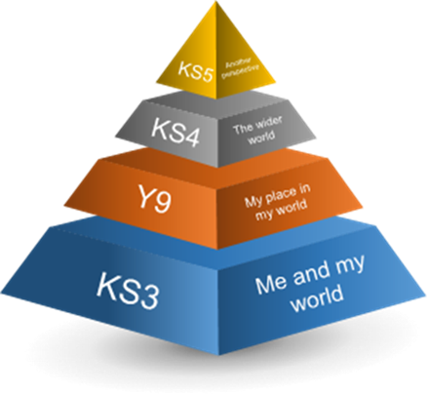
SUMMER TERM | TOPIC 5 Die Politik und die Jugend
SUMMER TERM | Political engagement among young people in the German-speaking world; the key points in youth politics; values and ideals.
SUMMER TERM | TOPIC 6 Rassismus
SUMMER TERM | The history of racism in the German- speaking world; the victims of racism; origins of racism; the fight against racism.

