German @ WBS Year 12 Roadmap
Subject Aim: The Year 12 German A level course builds on knowledge acquired at GCSE level but you will be encouraged to see the world from a broader perspective. There are 2 themes covered: Social Issues and Trends and Political and artistic culture.
In the Spring term you will also start studying the literature component of the course in the form of a film. You will be using the OUP course and the associated Kerboodle package.
Grammar is consolidated throughout and more advanced points are covered.
 | TOPIC 1 Die Familie im Wandel | ASSESSMENT IN YEAR 12
AUTUMN TERM | Family relationships; problems within families; marriage and partnerships; the role of the father; the evolving state of the family; different types of family; multi-generational families. | There will be 4 Key assessments plus a mock exam in Year 12.  Assessments will be set upon completion of each module and will test a variety of skills. The mock will be an AS Paper 1 which will assess listening, reading, translation and summarising skills.
AUTUMN TERM | TOPIC 2 Die digitale Welt | HOMEWORK IN YEAR 12
 | The internet; the benefits and dangers of social networks; the digitalisation of society. | Homework is used to consolidate and expand upon work done in the classroom. A variety of tasks will be set.
 | TOPIC 3 Jugendkultur | REVISION FOR ASSESSMENTS IN YEAR 12
SPRING TERM SUMMER TERM | Fashion and the importance of image; different types of music and television in the German-speaking world. | Reminders of assessments will be set on BrightSpace. Each assessment tests accumulated linguistic and factual knowledge.
SPRING TERM SUMMER TERM | TOPIC 4 Das Berliner Kulturleben | ENRICHMENT THEMES IN YEAR 12
SPRING TERM SUMMER TERM | The geography and history of Berlin; theatre, music and museums; Bertolt Brecht; the diversity of Berlin. | The whole of the A level course provides enrichment to the students through the study of artistic, social and political themes.  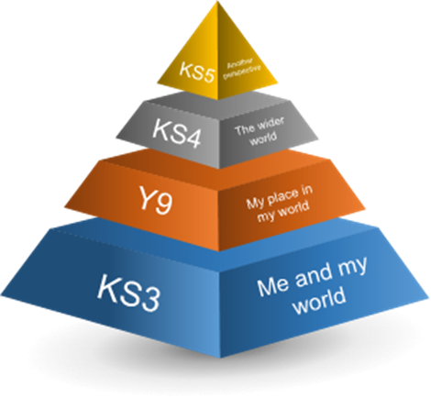
SPRING TERM SUMMER TERM | TOPIC 5 Kunst und Architektur
SPRING TERM SUMMER TERM | German, Swiss and Austrian artists and architects; Expressionism; art and architecture in our everyday lives; the past, present and future of the arts and architecture in the German-speaking world.
SPRING TERM SUMMER TERM | Topic 6 Feste und Traditionen
SPRING TERM SUMMER TERM | The origins of a variety of German, Swiss and Austrian traditions; their social and economic importance; regional customs in the German-speaking world.
Where Next?
In Year 13 you will expand your knowledge by studying themes of global importance. You will study a book or a play and develop your analytical skills.

